Daily Progress Report

Installation / Location | PS-3
Subject | Corrosion Monitoring Activities
Contract Number | LC241047A0
Assigned Petromech Representatives | Shuaib Palakkavalappil
Date of Issue | 25-08-2025

Activities Summary
Work activities at PS-3 continued today, Due to Heat Index we started the work lately. Work commenced today, starting with Corrosion Coupon Retrieval at 1 location.
Corrosion Coupon Retrievals and ER Probe replacement also started late in the afternoon, with 2 locations being serviced. Further details of the se locations can be found below.

Time | Activities
06:00 to 10:30 | Proceed to dock, board vessel to PS-3.Make arrangements for work permits to be issued, Due to heat index permit issued lately
10:30 to 11:30 | Commence Coupon Retrieval
11:30 to 12:30 | Lunch
12:30 to 16:30 | Continue ER Probe Replacement and Coupon Retrieval
16:30 to 18:30 | Proceed to dock, board vessel to PS-3

Locations Serviced Summary
Tag No | Line Description | Work Completed
53-XCC-1428 | 18-OCP-530235-15151  18” Crude inlet to V-5356 | Removed & Replaced 3” Strip Coupons. Retrieved 12.25” strip holder and Replaced 16.5” strip holder. Replaced all pressure retaining seals
53-XCP-1427 | 18-OC-530235-15151  18” Crude inlet to V-5356 | Probe location Serviced, Removed old 13.5” Type :B ER Probe and Replaced 17.75” Type :D ER Probe
Not Available | 6-GC-430036 | Protective cover jammed

Tag No | Line No / Description | Pressure  (psi) | A/F Orientation | Scope of Work | Retrieved Coupons ID /  Holder Length | Coupon Appearance | Installed Coupons ID / Weight / Material | Tool Used | Location Access | Remedial Actions
53-XCC-1428 | 18-OCP-530235-15151  18” Crude inlet to V-5356 | 100psi | 12 o Clock | Remove & Replace Corrosion Coupons | MQ035 & MQ036  Holder – 12.25” | Dark in colour small amount of soft deposits | NE652 – 36.7398g  NE653 – 36.8152g  Holder-16.5”  25-08-2025 | 37”RBS Retrieval Tool | Not Accessible Elevated Level | Permanent Service platform Required
Access Fitting Photograph |  |  |  | Retrieved Coupons / Device Photograph |  |  | Installed Coupons / Device Photograph
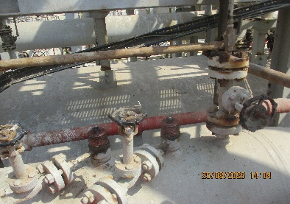  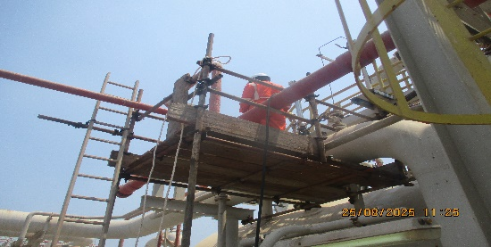 |  |  |  | 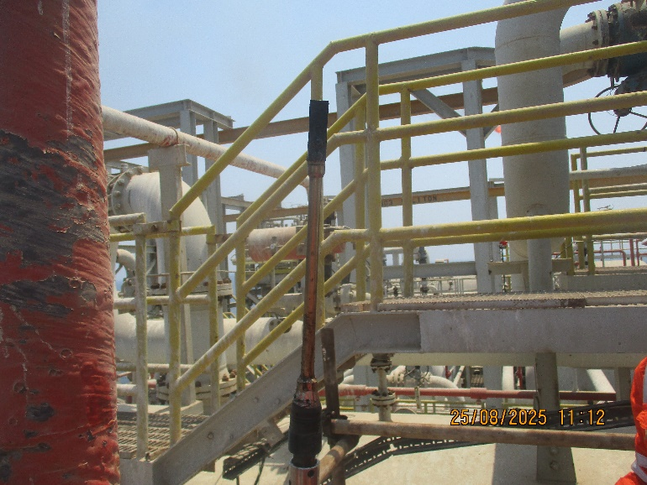 |  |  | 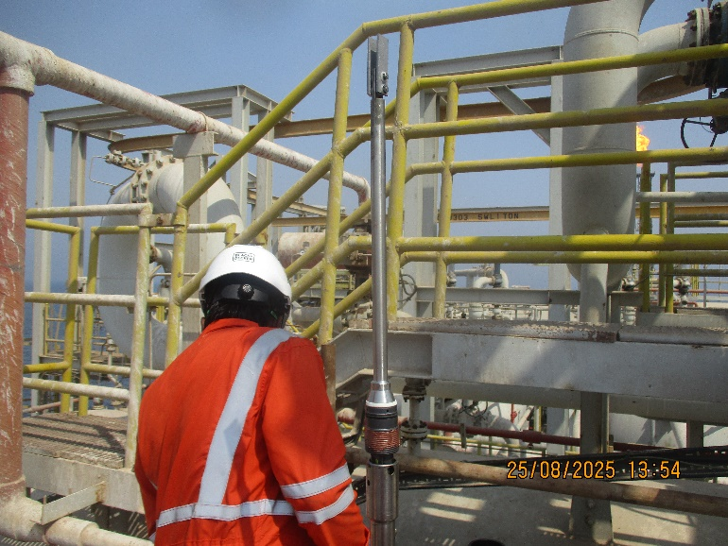
Comments
Access at Elevated Level, Permanent Service Platform Required

Tag No | Line No / Description | Pressure  (psi) | A/F Orientation | Scope of Work | Retrieved Coupons ID /  Holder Length | Installed Coupons ID / Weight / Material | Date | Tool Used | Location Access | Remedial Actions
Not Available | 6-GC-430036 | 200 | 6 o Clock | Remove & Replace Corrosion Coupons | N/A- Protective cover Jammed | N/A | 25-08-2025 | N/A | Access Elevated level | Scaffolding Required
 |  |  |  | Access Fitting Picture
 |  |  |  | 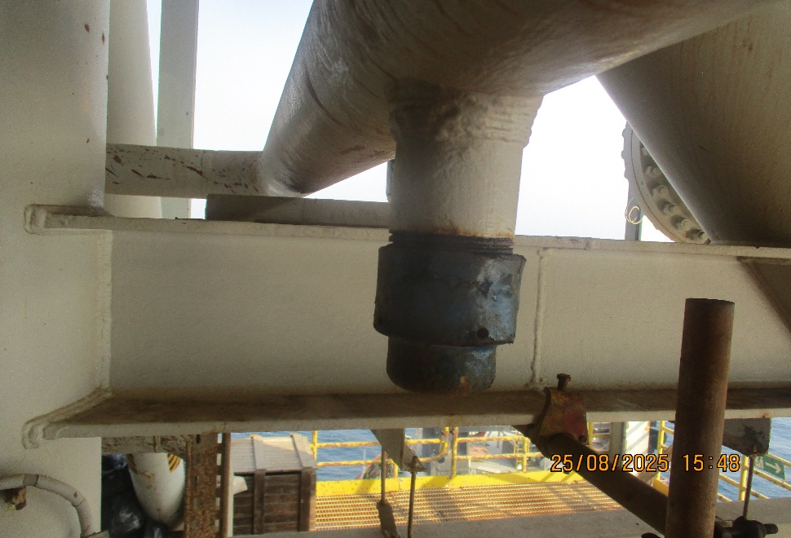
Comments
Access at Elevated Level, Scaffolding Required. Protective cover Jammed

Tag No | Line No / Description | Pressure  (psi) | A/F Orientation | Scope of Work | Retrieved Probe Type/ S/N | Installed Probe Type / Reading | Installed Date | Tool Used | Location Access | Remedial Actions
53-XCP-1427 | 18-OC-530235-15151  18” Crude inlet to V-5356 | 100 | 12 o Clock | Remove & Replace ER PROBE | 4705-S8-K03005-13.5”-1 Type:B  Installed Date: 25-05-2019 | 4500-T10-K03005-17.75-0-0  Check -771  Div-76.8 | 25-08-2025 | 37” RBS Retrieval tool | Not Accessible Elevated Level | Permanent Service platform Required
Access Fitting Photograph |  |  |  | Retrieved Coupons / Device Photograph |  |  | Installed Coupons / Device Photograph
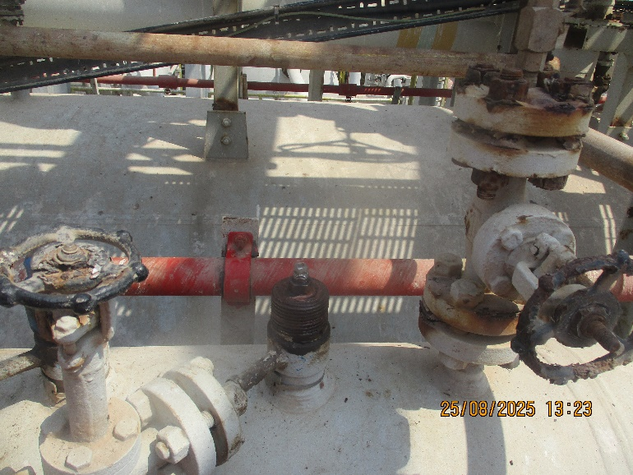 |  |  |  | 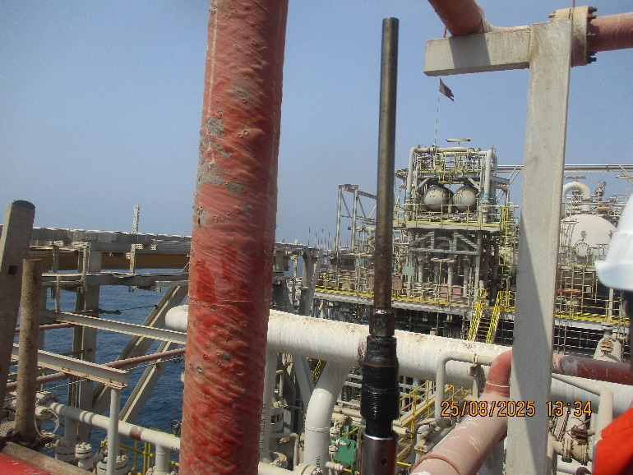 |  |  | 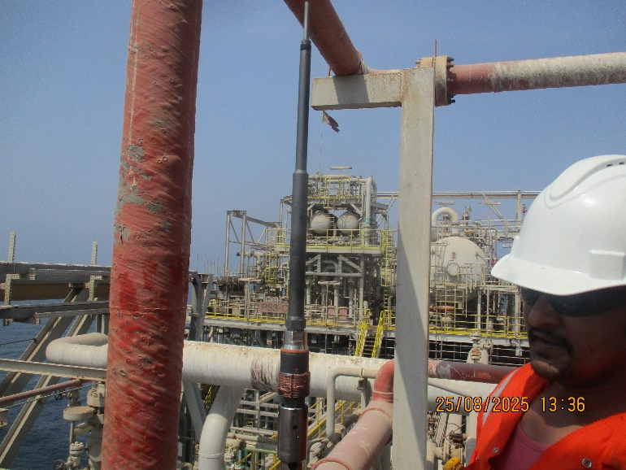
Comments
Access at Elevated Level, Permanent Service Platform Required

Observations & Recommendations
It was noticed during the ER Probe Service and Corrosion Coupon Replacement at 53-XCP-1427&53-XCC-1428 Respectively that both the access at elevated level ,Permanent Service Platform Required

24 Hour Lookahead
The pending works at PS-3 Completed by Today

Shuaib Palakkavalappil –Petromech. – shuaib.p@petromech.com.qa

